**Writing**

**Day 4: Organization**

Daily Lesson Plan

# Lesson Summary

In this lesson, students will examine the organization of an essay to make an effective argument. Teacher and students will examine and practice both essay-level and paragraph-level organization.

* **Step 1: Set Purpose/Activate Prior Knowledge—**Students will complete Entry Ticket activity to examine and order statements from an argumentative essay.
* **Step 2: I Do It/We Do It Together—**Teacher and students will discuss basic organization of an argumentative essay and effective organization within the body of an essay.
* **Step 3: You Do It Together—**Following teacher model on previous step, students will collaborate to identify and to order sentences within a body paragraph.
* **Step 4: Independent Application—**Students will work independently to label paragraphs to organize sample into introduction, body, and conclusion. Students will identify transition words that make organization clear.

# Objective

Students will understand and incorporate an organizational strategy with clear transitions.

# Engagement Strategies

* **Pair and Share:** Students will turn to a partner and collaborate through discussion. See also, [Remote Engagement: Pair and Share](https://projecttopeka.com/-/media/Topeka/Resources/Resource-Materials/Remote/PairShare.pdf).
* **Small Group Collaboration:** Students will work together to organize a sample paragraph. See also, [Remote Engagement: Small Groups](https://projecttopeka.com/-/media/Topeka/Resources/Resource-Materials/Remote/SmallGroup.pdf).

Links to information for remote learning are also provided in the lesson steps below. A complete list can be found in Appendix B.

# Scaffolding Strategies

The scaffolding strategies listed below are optional supports included in the lesson’s activities. These tools may be used or ignored based on students’ needs.

* **Vocabulary Bank:** Students, particularly students who are also English Learners, can use or even translate these words to note specific details in the text.
* **Sentence Stem Bank:** Students can use sentence stems to articulate their critical thinking about key aspects of the activities.
* **Issues Bank**: Students can use the Issues Bank to find key terms designed to help them express reasoning about evidence and examples.

# Key Vocabulary

* Introduction
* Body
* Conclusion
* Claim
* Reasons
* Evidence
* Reasoning

See bolded words and definitions throughout the lesson's text.

# Materials

* [Presentation](https://projecttopeka.com/-/media/Topeka/Resources/Resource-Materials/Writing-Unit/Writing-4/WRT_D4_Presentation.pptx)
* [Entry Ticket—Organization](https://projecttopeka.com/-/media/Topeka/Resources/Resource-Materials/Writing-Unit/Writing-4/WRT_D4_EntryTicket.docx)
* [Activity—Argument Sort](https://projecttopeka.com/-/media/Topeka/Resources/Resource-Materials/Writing-Unit/Writing-4/WRT_D4_ArgumentSort.docx)

# Standards Addressed in this Lesson

* Write arguments to support claims in an analysis of substantive topics or texts using valid reasoning and relevant and sufficient evidence. (CCSS.ELA-LITERACY.CCRA.W.1)
* Produce clear and coherent writing in which the development, organization, and style are appropriate to task, purpose, and audience. (CCSS.ELA-LITERACY.CCRA.W.4)
* Draw evidence from literary or informational texts to support analysis, reflection, and research. (CCSS.ELA-LITERACY.CCRA.W.9)

# Lesson Steps

## **Step 1:** Set Purpose/Activate Prior Knowledge

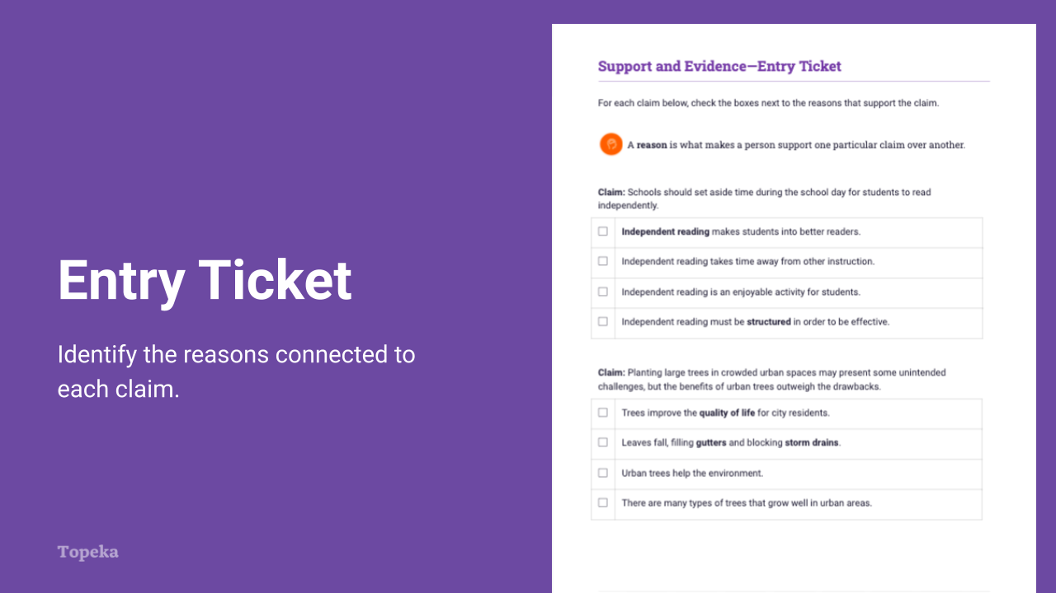

Slide 2

|  |  |
| --- | --- |
| **Teacher** | **Students** |
| Teacher sets the purpose for the class with an Entry Ticket activity to activate prior knowledge. | Students read four brief paragraphs from a sample essay. They will label the paragraphs, Introduction, Body 1, Body 2, and Conclusion. They underline the transition words that make organization clear. |
| Teacher invites students to Pair and Share with a classmate to discuss their answers.  For information on implementing Pair and Share via remote learning, see [Remote Engagement: Pair and Share](https://projecttopeka.com/-/media/Topeka/Resources/Resource-Materials/Remote/PairShare.pdf) or the guide to [Remote Learning with Topeka](https://projecttopeka.com/-/media/Topeka/Resources/Resource-Materials/Remote/RemoteLearning.pdf).  Take a moment to talk to your neighbor about the organization and transition words you identified. Explain your answers. | Students will turn to a neighbor and talk about their answers and why they chose them. |

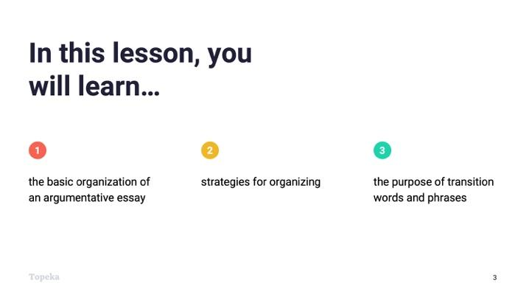

Slide 3

|  |  |
| --- | --- |
| **Teacher** | **Students** |
| Teacher presents learning objectives for session.  In earlier lessons we discussed the importance of having a good claim and strong support for the argument. Today we’re going to discuss how an argument should be organized, including   * the basic organization of an argumentative essay; * strategies for organizing body paragraphs; and * the purpose of transition words and phrases for enhancing organization. | Students will listen and take notes. |

## **Step 2:** I Do It/We Do It Together

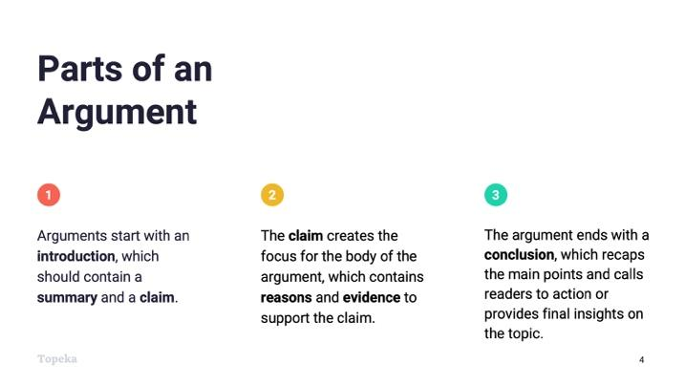

Slide 4

|  |  |
| --- | --- |
| **Teacher** | **Students** |
| Teacher explains the basic parts of an argumentative essay: Introduction, Body, Conclusion.  Consider pre-recording this portion of the lesson for remote delivery. See the guide to [Remote Learning with Topeka](https://projecttopeka.com/-/media/Topeka/Resources/Resource-Materials/Remote/RemoteLearning.pdf) for more details. | Students listen and participate in teacher modeling. |
| Teacher presents brief description of each part. See Slide 4 for text. |  |

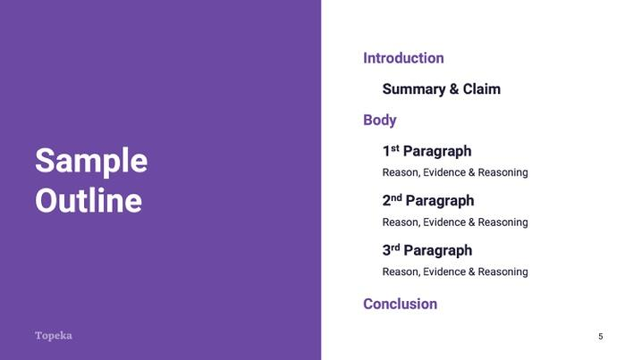

Slide 5

|  |  |
| --- | --- |
| **Teacher** | **Students** |
| Teacher walks through how these parts look when placed in an outline.  This is an outline of a brief argumentative essay. At the very beginning you have the introduction, which *must* contain your claim, and *should* contain a brief description or summary of the “ongoing issue.”  After the introduction comes the body, which contains your support for your claim. Each paragraph in the body should provide a reason for your claim, evidence connected to the reason, and an explanation of how the evidence connects back to the claim. This explanation is your reasoning.  Finally you have a conclusion. Your conclusion should wrap up the argument. It should restate your claim and provide a brief summary of how you proved your position.  Teacher continues to explain organization in the context of the Entry Ticket.  Let’s return to the Entry Ticket. Who can tell me what the introduction to the argument is? | Students listen and take notes. |
| Pause to allow a student to answer: “At some hospitals, caregivers use ‘carebots’ designed to comfort patients. Although robotic pets can benefit the elderly, human companionship is better than carebots.”  How do you know this? Because this paragraph provides the claim. | Students contribute with answers from Entry Ticket activity. |

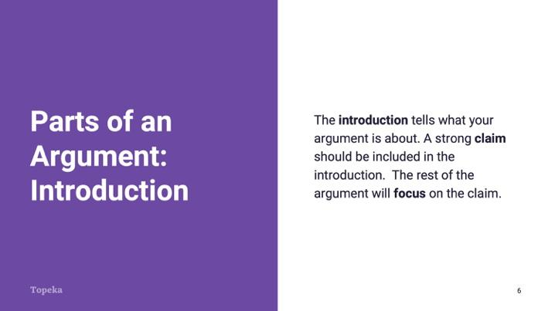

Slide 6

|  |  |
| --- | --- |
| **Teacher** | **Students** |
| Teacher continues.  The introduction tells what your argument is about. A strong claim should be included in the introduction. The rest of the argument will focus on the claim. | Students listen and take notes. |

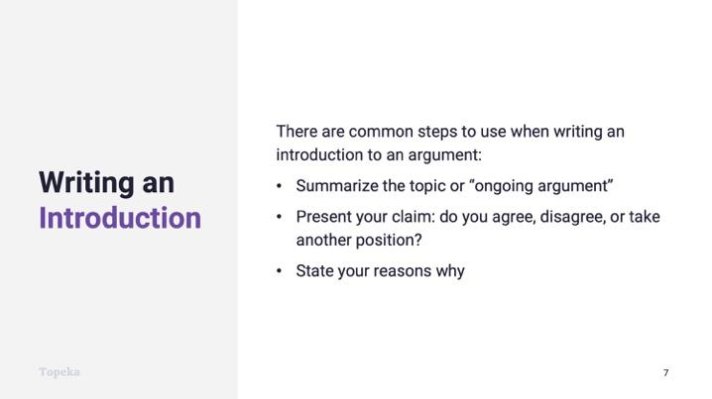

Slide 7

|  |  |
| --- | --- |
| **Teacher** | **Students** |
| Teacher continues.  The introduction in the worksheet is just a couple of sentences. In your essays you'll want to provide more than that, and there are steps you can take to build a great introduction.  First, a great way to show that you understand the topic you're writing about is to summarize the "ongoing argument" that you read about in the text. For example, in a complete essay on this topic, the introduction might contain a longer summary with more detail about the text that this is based on.  Then you present your claim. Do you agree, disagree, or take another position? For example: “Although robotic pets can benefit the elderly, human companionship is better than carebots."  If space allows, you can give a very brief overview of the reasons you’ll present in the body of the essay. | Students listen and take notes. |

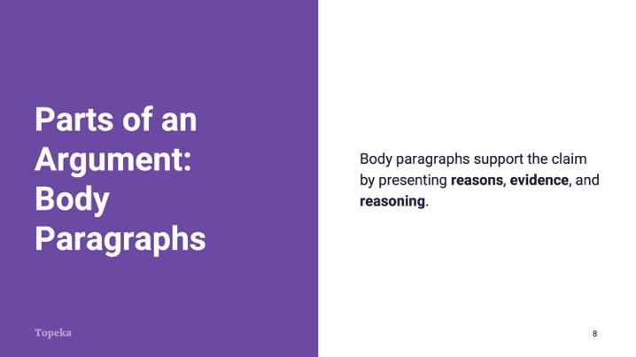

Slide 8

|  |  |
| --- | --- |
| **Teacher** | **Students** |
| Teacher presents explanation of body paragraph structure.  After the introduction comes the body of your argument. This is where you present the reasons and evidence for your claim and explain with reasoning how your reasons and evidence connect to the claim. | Students listen and take notes. |

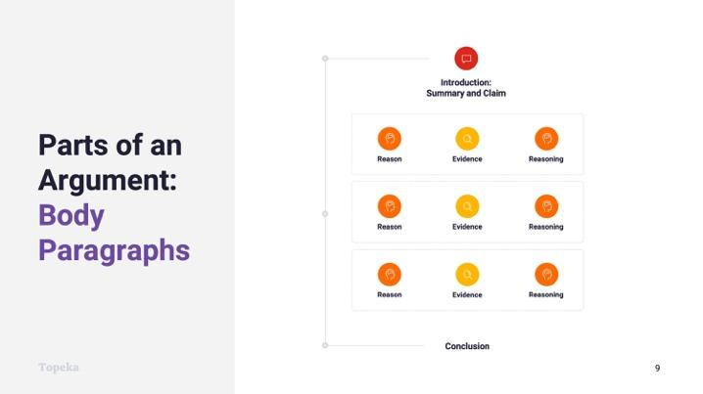

Slide 9

|  |  |
| --- | --- |
| **Teacher** | **Students** |
| Teacher presents construction of body paragraphs.  Your body paragraphs should be carefully constructed to make sure they are focused on supporting the claim.  Take a look at this graphic. In a typical argument, within each of the body paragraphs you'll find   * a reason; * evidence from the text; and * and reasoning that provides an explanation of how the reason and evidence connect to each other and to the claim.   Let's look at an example. | Students listen and take notes. |

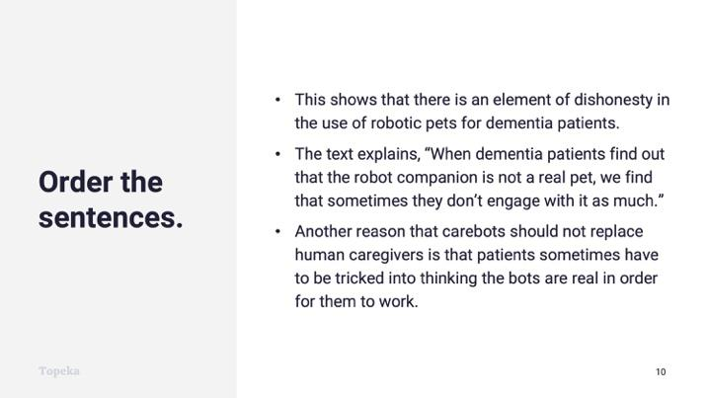

Slide 10

|  |  |
| --- | --- |
| **Teacher** | **Students** |
| Teacher leads students through whole-class ordering of sentences into an effective reason paragraph in the Paragraph Sort Activity.  Here are three sentences that we can put together to create another reason for the essay from the Entry Ticket. Let's create a body paragraph here.  Read these sentences and tell me which one provides the reason. That's what we would put first. | Students listen and take notes. |
| Teacher pauses to allow students to participate.  What should follow the sentence that states the reason? | Students offer answers and explain their thinking. |
| Teacher pauses to allow students to participate.  Which leaves the third sentence to connect the reason and evidence back to the claim. | Students offer answers and explain their thinking. |
| Teacher has someone read the entire paragraph in order. | Selected student will read the three sentences in order. |

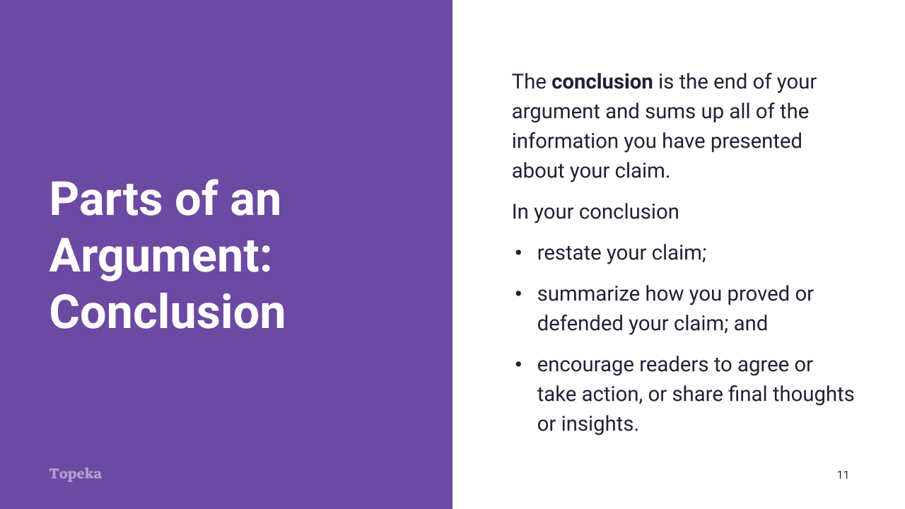

Slide 11

|  |  |
| --- | --- |
| **Teacher** | **Students** |
| Teacher explains the purpose of the conclusion.  At the end of the essay is the conclusion. The conclusion sums up all of the information you have presented about your claim.  What conclusion did you identify in the Entry Ticket? How did you know? | Students listen and take notes. |
| Teacher pauses to allow students to participate.  In your conclusion you should restate your claim. A strong conclusion will summarize how you proved or defended your claim and encourage readers to agree or take action, or give them a final thought to take away.  What is the final thought in the sample from the activity? | Students offer answers and explain their thinking. |
| Teacher pauses to allow students to participate. | Students offer answers and explain their thinking. |

## **Step 3:** You Do It Together

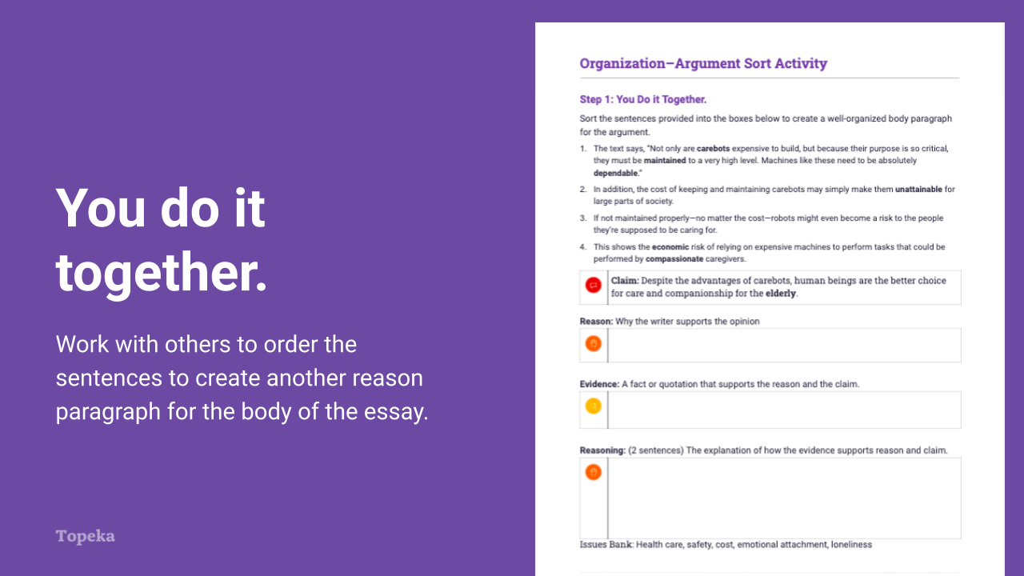

Slide 12

|  |  |
| --- | --- |
| **Teacher** | **Students** |
| Using Paragraph Sort Activity, Teacher divides class into pairs or small groups to begin Step 1 and repeat the process sorting sentences into a unified reason paragraph.  For information on implementing Small Group Collaboration via remote learning, see [Remote Engagement: Small Groups](https://projecttopeka.com/-/media/Topeka/Resources/Resource-Materials/Remote/SmallGroup.pdf) or the guide to [Remote Learning with Topeka](https://projecttopeka.com/-/media/Topeka/Resources/Resource-Materials/Remote/RemoteLearning.pdf).  When finished, teacher leads class through debrief to discuss students’ answers and explanations. | Students sort another paragraph in a small group and share findings with the whole class. |

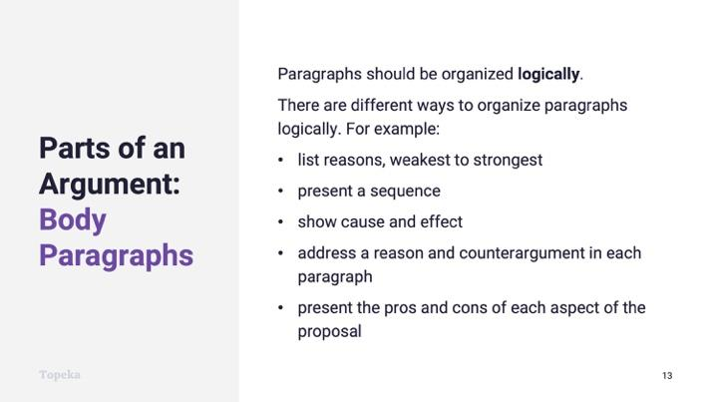

Slide 13

|  |  |
| --- | --- |
| **Teacher** | **Students** |
| Teacher continues.  Now that you know how to organize your thoughts into a reason paragraph, you can think about how to organize your reasons.  Body paragraphs should be organized logically.  There are different ways to organize paragraphs logically (refer to Slide 13):   * By reasons, weakest to strongest * By sequence or cause and effect * By addressing a reason and counterargument in each paragraph * By listing all the pros, then all the cons   When you make a decision about how to organize your reasons, you can make that decision clear by using good transitions. | Students listen and take notes. |

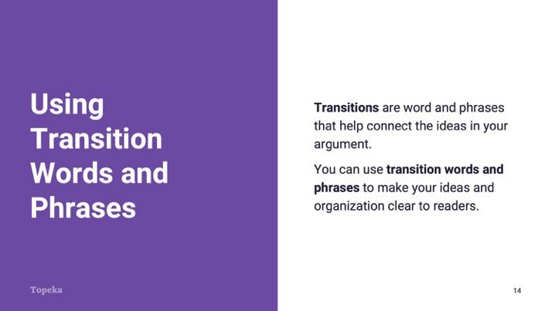

Slide 14

|  |  |
| --- | --- |
| **Teacher** | **Students** |
| Teacher presents transitions to make organization clear.  Transitions are words and phrases that help connect the ideas in your argument.  Transitions serve many purposes. One purpose is to make your organization clear to readers. | Students listen and take notes. |

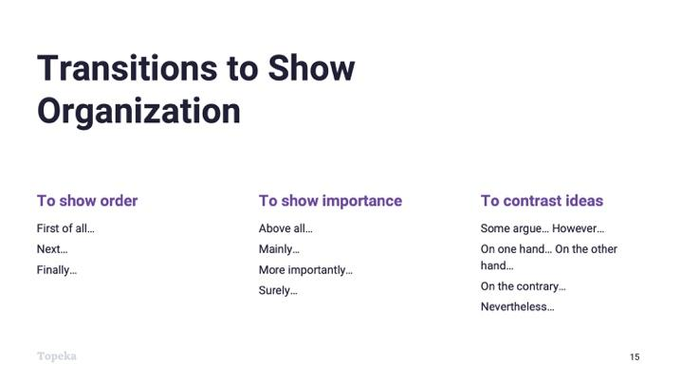

Slide 15

|  |  |
| --- | --- |
| **Teacher** | **Students** |
| For example, if you want to show things in a sequential order, you can use “First,” “Second,” “Third,” or “First,” “Next,” “Finally.”  If you want to show things in order of importance, you might use “First,” “More importantly,” and “Above all.”  If you have arranged your reason paragraphs to respond to counterarguments, you might use “Some argue” and “However,” or something similar. |  |

## **Step 4:** Independent Application

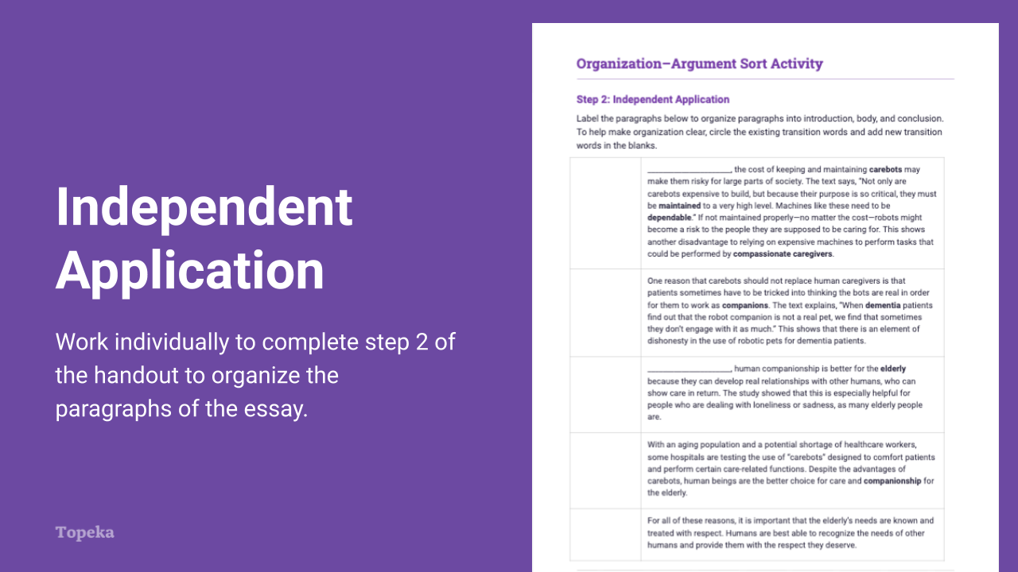

Slide 16

|  |  |
| --- | --- |
| **Teacher** | **Students** |
| Teacher has students turn to Step 2 of the Argument Sort Activity.  Now you will practice organizing these paragraphs into an argumentative essay again. Label the paragraphs and then add transition words to show the organization strategy you’re using. | Students listen and take notes. |
| Teacher circulates to provide support as needed. | Individually, students will complete Step 2 of the exercise. |
| If time allows, teacher leads students in a full-class debrief of the exercise. | Students will participate and revise answers on their worksheets as time allows. |

# Appendix A: Sample Responses

## Organization—Entry Ticket

|  |  |
| --- | --- |
| **Carebots or Humans: Who Should Care for the Elderly?** | |
| Body 1 | First of all, human companionship is better for the elderly because they can develop real relationships with other humans, who can show care in return. The study showed that this is especially helpful for people who are dealing with loneliness or sadness, as many elderly people are. |
| Introduction | At some hospitals, caregivers use “carebots” designed to comfort patients at a lower cost than human workers. Although these robotic pets can benefit the elderly and hospitals, human companionship is better than carebots. |
| Conclusion | Above all, it is important that the elderly’s needs are known and treated with respect. Humans are best able to recognize the needs of other humans and provide them with the respect they deserve. |
| Body 2 | Also, some people worry that caregivers might begin depending on robots to keep people company instead of doing it themselves. In the text Professor Salamon says, “we should build carebots not to replace human caregivers but to help them do their jobs better.” This means that carebots should definitely be used, but only in addition to regular human companionship. |

## 

## Argument Sort Activity

|  |  |
| --- | --- |
| Body | Secondly, the cost of keeping and maintaining carebots may make them risky for large parts of society. The text says, “Not only are carebots expensive to build, but because their purpose is so critical, they must be maintained to a very high level. Machines like these need to be dependable.” If not maintained properly—no matter the cost—robots might become a risk to the people they are supposed to be caring for. This shows another disadvantage of relying on expensive machines to perform tasks that could be performed by compassionate caregivers. |
| Body | One reason that carebots should not replace human caregivers is that patients sometimes have to be tricked into thinking the bots are real in order for them to work as **companions**. The text explains, “When **dementia** patients find out that the robot companion is not a real pet, we find that sometimes they don’t engage with it as much.” This shows that there is an element of dishonesty in the use of robotic pets for dementia patients. |
| Body | Most importantly, human **companionship** is better for the elderly because they can develop real relationships with other humans, who can show care in return. The study showed that this is especially helpful for people who are dealing with loneliness or sadness, as many elderly people are. |
| Introduction | With an aging population and a potential shortage of healthcare workers, some hospitals are testing the use of “carebots” designed to comfort patients and perform certain care-related functions. Despite the advantages of carebots, human beings are the better choice for care and companionship for the elderly. |
| Conclusion | For all of these reasons, it is important that the elderly’s needs are known and treated with respect. Humans are best able to recognize the needs of other humans and provide them with the respect they deserve. |

# Appendix B: Engagement Strategies Via Remote Learning

The following links provide useful information for implementing this lesson through remote learning:

* [Remote Learning with Topeka](https://projecttopeka.com/-/media/Topeka/Resources/Resource-Materials/Remote/RemoteLearning.pdf).
* [Remote Engagement: Pair and Share](https://projecttopeka.com/-/media/Topeka/Resources/Resource-Materials/Remote/RemoteLearning.pdf)
* [Remote Engagement: Small Groups](https://projecttopeka.com/-/media/Topeka/Resources/Resource-Materials/Remote/SmallGroup.pdf)